|  |  |
| --- | --- |
|  | Foundation Activity 3 Parallel and Series Connections |

Learning Outcomes

Students will,

1. Visualize the movement of electricity in parallel and series connections
2. Build buzzer circuits to experiment with adding resistors in parallel and in series

This activity should take **~1 hour (1.5 hours recommended)** to complete:

[Materials and Costs per Student 2](#_Toc517787979)

[Lesson 2](#_Toc517787980)

[Activity Overview (5 minutes) 2](#_Toc517787981)

[Parallel and Series Connections (5 minutes) 4](#_Toc517787982)

[Parallel and Series Examples (15 minutes) 4](#_Toc517787983)

[Buzzer Circuit 1 – Series Resistors (10 minutes) 6](#_Toc517787984)

[Buzzer Circuit 2 – Parallel Resistors (10 minutes) 6](#_Toc517787985)

[Reflection – Resistors in Parallel and Series (10 minutes) 6](#_Toc517787986)

[Debrief Discussion (5 minutes) 8](#_Toc517787987)

[Challenge and Explore 9](#_Toc517787988)

[Frequently Asked Questions 10](#_Toc517787989)

Materials and Costs per Student

Assuming one kit of parts per student:

|  |  |  |  |  |
| --- | --- | --- | --- | --- |
| Item | Qty. | Cost per Student[1](#fn:1) | Expendable[2](#fn:2) | Supplier |
| Push Button | 3 | 0.07 | y | [Aliexpress](https://www.aliexpress.com/item/Free-Shipping-100PCS-2-pins-6-6-5-mm-Switch-Tactile-Push-Button-Switches-6x6x5mm/1393753898.html?spm=2114.01010208.3.89.VeW6Y6&ws_ab_test=searchweb0_0,searchweb201602_3_10152_10065_10151_10130_10068_10139_10136_10137_10060_10155_10062_437_10154_10056_10055_10054_10059_303_100031_10099_10103_10102_10096_10052_10053_10142_10107_10050_10051_5030013_10084_10083_10080_10082_10081_10178_10110_519_10111_10112_10113_10114_10182_10078_10079_10073_10123_10189_142,searchweb201603_9,ppcSwitch_4&btsid=0ad2c9e1-e4e3-419e-8f32-c9bb7d9ded7c&algo_expid=5c4bcdb3-acce-4f8a-9f45-fbd33bf2db3b-11&algo_pvid=5c4bcdb3-acce-4f8a-9f45-fbd33bf2db3b) |
| Piezo Buzzer 5V 12mm | 1 | 0.19 |  | [Aliexpress](https://www.aliexpress.com/item/10pcs-5v-Active-Buzzer-Magnetic-Long-Continous-Beep-Tone-Alarm-Ringer-12mm-MINI-Active-Piezo-Buzzers/32620122626.html?spm=2114.10010108.1000014.9.cEh4tF&traffic_analysisId=recommend_3035_5_83087_icosac&scm=1007.13338.83087.0&pvid=6477b8b5-e4ca-4223-acb2-99890cbd10f4&tpp=1) |
| Resistors 1/4w, 3x 100 ohm, 3x 470ohm | 6 | 0.04 | y | [Aliexpress](https://www.aliexpress.com/item/Total-2100pcs-1-1-4W-Metal-Film-Resistor-Assorted-Kit-21-Values-1-Ohm-1M-Ohm/1065989389.html?spm=2114.01010208.3.49.E1lT47&ws_ab_test=searchweb0_0,searchweb201602_3_10152_10065_10151_10130_10068_10139_10136_10137_10060_10155_10062_437_10154_10056_10055_10054_10059_303_100031_10099_10103_10102_10096_10052_10053_10142_10107_10050_10051_5030013_10084_10083_10080_10082_10081_10178_10110_519_10111_10112_10113_10114_10182_10078_10079_10073_10123_10189_142-normal#cfs,searchweb201603_9,ppcSwitch_4&btsid=c29fad75-42b1-4f39-a439-a6d88e149c80&algo_expid=8316255e-6bd9-4140-b171-8a451ea8713a-6&algo_pvid=8316255e-6bd9-4140-b171-8a451ea8713a) |
| 9V Battery Snap | 1 | 0.16 |  | [Aliexpress](https://www.aliexpress.com/item/Fast-shipping-UNO-R3-9V-Battery-Connector-9V-battery-clip-for-arduino-12pcs-lot-in-stock/1954763219.html?spm=2114.01010208.3.1.EedDHa&ws_ab_test=searchweb0_0,searchweb201602_3_10152_10065_10151_10130_10068_10139_10136_10137_10060_10155_10062_437_10154_10056_10055_10054_10059_303_100031_10099_10103_10102_10096_10052_10053_10142_10107_10050_10051_5030013_10084_10083_10080_10082_10081_10178_10110_519_10111_10112_10113_10114_10182_10078_10079_10073_10123_10189_142,searchweb201603_50,ppcSwitch_4&btsid=8e904185-6e84-42e6-b2e3-4c1c951dda29&algo_expid=1ce3b53a-b6bb-4b51-99be-2a97119d63bb-0&algo_pvid=1ce3b53a-b6bb-4b51-99be-2a97119d63bb) |
| Jumper Cables MM 10cm | 4 | 0.08 | y | [Aliexpress](https://www.aliexpress.com/item/Free-shipping-Dupont-line-120pcs-10cm-male-to-male-male-to-female-and-female-to-female/32714431608.html?spm=2114.13010308.0.0.FYFaeT) |
| Breadboard 400 point | 1 | 1.49 |  | [Aliexpress](https://www.aliexpress.com/item/Free-Shipping-10pc-Quality-mini-bread-board-breadboard-8-5CM-x-5-5CM-400-holes/1785291644.html?spm=2114.01010208.3.129.v6wyGQ&ws_ab_test=searchweb0_0,searchweb201602_3_10152_10065_10151_10130_10068_10139_10136_10137_10060_10155_10062_437_10154_10056_10055_10054_10059_303_100031_10099_10103_10102_10096_10052_10053_10142_10107_10050_10051_5030013_10084_10083_10080_10082_10081_10178_10110_519_10111_10112_10113_10114_10182_10078_10079_10073_10123_10189_142,searchweb201603_50,ppcSwitch_4&btsid=6cedbe6d-dc4c-47ed-b942-d4fef5789d54&algo_expid=ca53d8d6-1460-4def-9635-9a5d78155ba8-16&algo_pvid=ca53d8d6-1460-4def-9635-9a5d78155ba8) |
| Breadboard Power Supply, 5V/3.3V | 1 | 0.75 |  | [Aliexpress](https://www.aliexpress.com/item/Best-price-10pcs-lot-MB102-Solderless-Breadboard-Power-Supply-Module-3-3V-or-5V/32505402973.html?spm=2114.01010208.3.121.o1lolF&ws_ab_test=searchweb0_0,searchweb201602_3_10152_10065_10151_10130_10068_10139_10136_10137_10060_10155_10062_437_10154_10056_10055_10054_10059_303_100031_10099_10103_10102_10096_10052_10053_10142_10107_10050_10051_5030013_10084_10083_10080_10082_10081_10178_10110_519_10111_10112_10113_10114_10182_10078_10079_10073_10123_10189_142,searchweb201603_50,ppcSwitch_4&btsid=ca59b36d-000d-43df-a83a-96852d809e96&algo_expid=f30d4306-9a10-4859-bd80-cc4729779eb5-15&algo_pvid=f30d4306-9a10-4859-bd80-cc4729779eb5) |
| 9V Ni-Mh 450mAh | 1 | 5.17 |  | [Aliexpress](https://www.aliexpress.com/item/Wholesales-8pcs-lot-ETINESAN-9v-450mAh-Ni-MH-Rechargeable-9-Volt-NiMH-Battery-Batteries-use-Camera/32535390438.html?spm=2114.01010208.3.170.Pujavd&ws_ab_test=searchweb0_0,searchweb201602_3_10152_10065_10151_10130_10068_10139_10136_10137_10060_10155_10062_437_10154_10056_10055_10054_10059_303_100031_10099_10103_10102_10096_10052_10053_10142_10107_10050_10051_5030013_10084_10083_10080_10082_10081_10178_10110_519_10111_10112_10113_10114_10182_10078_10079_10073_10123_10189_142,searchweb201603_50,ppcSwitch_4&btsid=7f174eeb-7335-4d1a-98d0-64862e5cf274&algo_expid=bc27a180-c5a4-4e39-bab4-c0693a22a2e0-21&algo_pvid=bc27a180-c5a4-4e39-bab4-c0693a22a2e0) |
| **Total Cost per Student** |  | **$7.95 CAD** |  |  |

1. *Currency is CAD, 2017-06-10. Assuming one set of parts per student.*
2. *Likely to be broken or lost during the activity.*

Each student should also get one printed copy of the activity handout.

Lesson

For further information, check out: [SparkFun – Parallel and Series Connections](https://learn.sparkfun.com/tutorials/series-and-parallel-circuits)[[1]](#footnote-1)

**Bold text** indicates directions or notes specifically for the instructor.

Activity Overview (5 minutes)

In the last activity we looked at a circuit diagram for an LED light and built the circuit on a breadboard. We also learned about nodes, a point where two or more parts are connected by a wire in a circuit diagram. There were four nodes in the LED circuit: (**draw the diagram below on the board**)

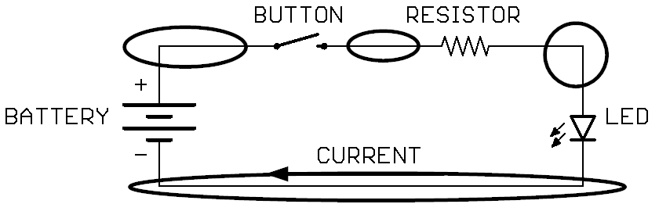

Where parts are connected together in a node, they have the same voltage at that node. So, in this diagram, if the battery is 5V, both the left side of the button and the (+) of the battery are at 5V because they are connected in a node. Similarly, the (-) side of the battery and bottom side of the LED are at 0V.

Some students were able to light up 2 LEDs or use 2 buttons to control the circuit. When combining the buttons one of two things happened:

1. Both buttons needed to be pressed to turn on the light. (**draw the diagram below on the board**)

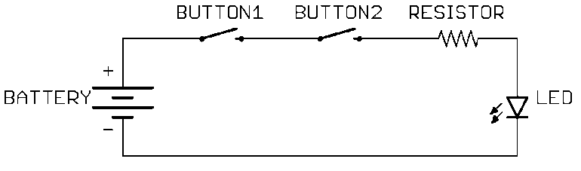

1. Either button could be pressed to turn on the light. (**draw the diagram below on the board**)

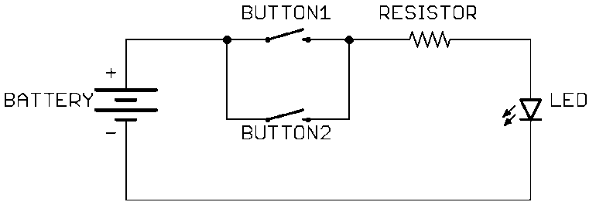

Today, we’re going to:

1. Learn why this happened, and the names for these types of connections: series and parallel
2. Build a buzzer circuit and use series and parallel connections to control the volume of the buzzer
3. Investigate how the total resistance changes when resistors are added in series and in parallel

Parallel and Series Connections (5 minutes)

**Instruct students on the difference between parallel and series connections: (draw each example circuit on the board before discussing it)**

|  |  |
| --- | --- |
| Parts in series are connected one after the other in a line.  The same current flows through all the parts, in a single path. |  |
| In this example, the buttons are in series. Since there is only one path for the current, both buttons must be pressed to turn on the LED. | C:\Users\Harryp\MEGA\Surface Pro 2\Nepal\Himalayan Makers Guild\Activities\Foundation Activities\FA3 - Series and Parallel Connections\images\2switch_LED_series.png |
| Parts in parallel are connected side-by-side.  Current flows in separate paths through a parallel circuit. The current entering the circuit is the same as the current leaving. The same voltage is applied across all the paths. |  |
| In this example, the buttons are in parallel. Since there are multiple paths where the current can flow, either button can be pressed to turn on the LED. | C:\Users\Harryp\MEGA\Surface Pro 2\Nepal\Himalayan Makers Guild\Activities\Foundation Activities\FA3 - Series and Parallel Connections\images\2switch_LED_parallel.png |

Parallel and Series Examples (15 minutes)

|  |  |
| --- | --- |
| Are these resistors and LED in series or in parallel?  A: In series. The same current will flow through each part as it goes from 5V to GND (0V). | C:\Users\Harryp\MEGA\Surface Pro 2\Nepal\Himalayan Makers Guild\Activities\Foundation Activities\FA3 - Series and Parallel Connections\images\Eagle\series_R_LED.png |
| Are these two resistors in series or in parallel?  A: In parallel. The current must split into two paths (through both resistors) as it flows from 5V, then recombines before flowing through the LED to GND. The top sides of the resistors are connected in one node, and the bottom sides of the resistors are connected in another node, so the same voltage is applied across both resistors. | C:\Users\Harryp\MEGA\Surface Pro 2\Nepal\Himalayan Makers Guild\Activities\Foundation Activities\FA3 - Series and Parallel Connections\images\Eagle\parallel_R_LED.png |
| Is R1 in series with R2?  A: Yes, the same current is flowing through all three parts, from the (+) side of the battery, through R1, the LED, then R2, and finally back to the (-) side of the battery. Since the same current flows through both R1 and R2 they are in series. Actually, because all the parts are together in series, we could change their order and the circuit will behave the same; the same current will still flow through each part (**redraw the first circuit with the two resistors after the LED**). Parallel parts can similarly be rearranged without affecting the circuit behavior. | C:\Users\Harryp\MEGA\Surface Pro 2\Nepal\Himalayan Makers Guild\Activities\Foundation Activities\FA3 - Series and Parallel Connections\images\Eagle\series_R_LED_R.png  C:\Users\Harryp\MEGA\Surface Pro 2\Nepal\Himalayan Makers Guild\Activities\Foundation Activities\FA3 - Series and Parallel Connections\images\Eagle\series_R_R_LED.png |
| How many nodes are there in this circuit, and where are they? | A: There are four nodes: |
| **C:\Users\Harryp\MEGA\Surface Pro 2\Nepal\Himalayan Makers Guild\Activities\Foundation Activities\FA3 - Series and Parallel Connections\images\Eagle\series parallel examples4.png** | **C:\Users\Harryp\MEGA\Surface Pro 2\Nepal\Himalayan Makers Guild\Activities\Foundation Activities\FA3 - Series and Parallel Connections\images\Eagle\series parallel examples4nodes.png** |
| How does the current flow through this circuit?Can someone come to the board and try drawing it in?  A: It flows in one path through R1 and R2, then at node C it splits into two paths through R3 and R4, then recombines at node D. | A:  C:\Users\Harryp\MEGA\Surface Pro 2\Nepal\Himalayan Makers Guild\Activities\Foundation Activities\FA3 - Series and Parallel Connections\images\Eagle\series parallel examples4current.png[[2]](#footnote-2) |
| Are R1 and R2 in series or in parallel?  A: They are in series because the same current flows through both parts in a single path.  Are R3 and R4 in series or in parallel?  A: They are in parallel because the current flows in two pathsthrough R3 and R4 between node C and node D and the same voltage is applied across each path. | |
| Is R3 in series with R2?  A: No! Current does not flow in a single path through R2 and R3. At node C the current splits between R3 and R4. Because the current in R2 is not the same current as in R3 and we cannot say they are in series. | |

Buzzer Circuit 1 – Series Resistors (10 minutes)

We’re going to build 2 circuits. First, a buzzer using resistors in series. Try 1, 2, then 3 resistors in series and see how the loudness/tone of the buzzer changes. **(Draw the diagram on the board)**  
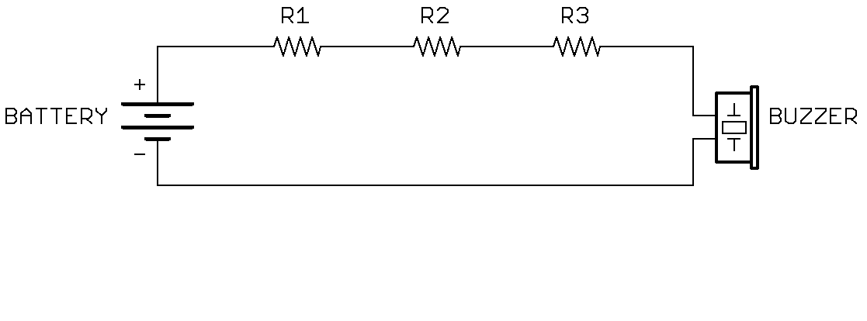

Note that the buzzer has a (+) side and a (-) side. The plus side has a slightly longer leg. Make sure the (+) side is connected towards the (+) side of the battery!

**Distribute the parts to the students, using the 100 ohm resistors (brown and black lines).**

Buzzer Circuit 2 – Parallel Resistors (10 minutes)

**Exchange the three 100 ohm resistors for three 470 ohm resistors (2 red lines). Ask the students to try 1, 2, and then 3 resistors in parallel and see how the volume of the buzzer changes. (Draw the following diagram on the board)**  
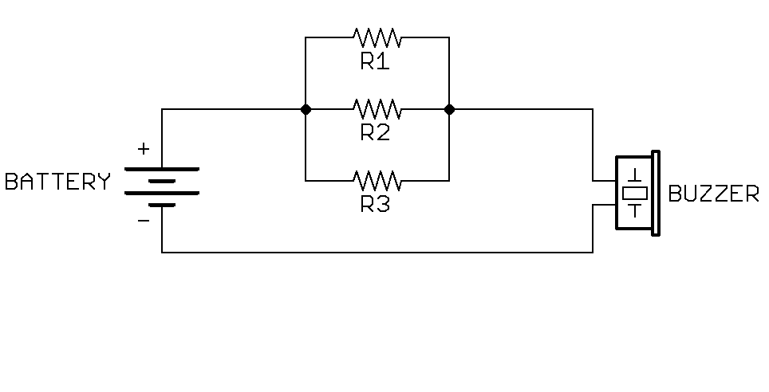

Reflection – Resistors in Parallel and Series (10 minutes)

**Ask the students to share their observations about the buzzer volume when adding resistors in parallel and in series and discuss how this affects current in the circuit.**

* How did the volume of the buzzer change when you added more resistors in series? A: It became quieter.
* **Draw the circuit on the board**. As we add more resistors in series in the buzzer circuit, do you think more or less current flows through the buzzer? A: less current flows through the buzzer, making it quieter.  
  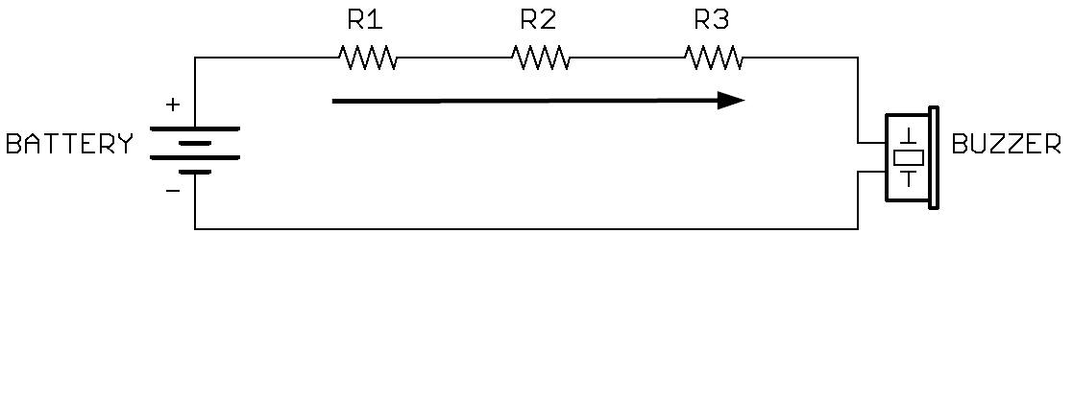
* How did the volume of the buzzer change when you added more resistors in parallel? A: It became louder.
* **Draw the circuit on the board**. As we add more resistors in parallel**,** will more or less current flow compared to when we used only one resistor? A: More current will flow, making the buzzer louder.  
  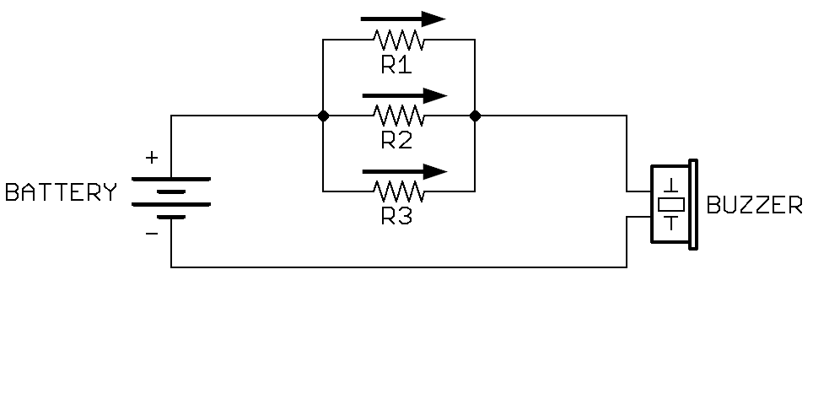

So, we observed that adding resistors in series increased the total resistance, allowing less current to flow and making the buzzer quieter. However, adding resistors in parallel decreased the total resistance, allowing more current to flow and making the buzzer louder. We can also use resistors in parallel or in series.

To understand how this works, imagine a small room crowded with people, where everyone is trying to exit through one door. This is like the circuit with one resistor; there is only one pathway for the current to flow through. However, if the same room has two doors, people can go through either one and exit more easily. This is like the circuit with resistors in parallel. Even though we’ve added a resistor, the current can flow through both resistors at the same time, reducing the total resistance and increasing the total current.

Considering the rockslide analogy, (**draw the rockslide analogy on the board**).

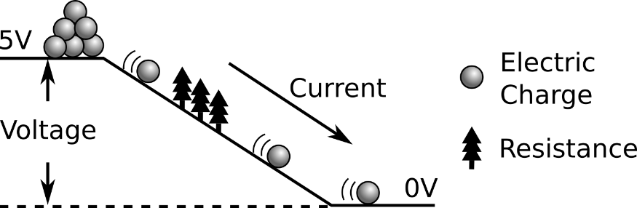

|  |  |
| --- | --- |
| Adding resistors in series is like adding more trees onto the hill. The rocks slide less easily through the extra trees. | C:\Users\Harryp\MEGA\Surface Pro 2\Nepal\Himalayan Makers Guild\Activities\Foundation Activities\FA3 - Series and Parallel Connections\images\rockslide series.png |
| Adding resistors in parallel is like adding another hill of the same height for the rocks to slide down. So, even though we’ve added more trees, rocks can slide down both hills at the same time. | C:\Users\Harryp\MEGA\Surface Pro 2\Nepal\Himalayan Makers Guild\Activities\Foundation Activities\FA3 - Series and Parallel Connections\images\resistors parallel no legend.png |

Debrief DISCUSSION (5 minutes)

**Encourage a discussion among the students for them to share their thoughts on the activity.**

Today we used resistors in series and in parallel to change the amount of current flowing through a buzzer. Why is this important? What applications does this have? Possible answers include:

* Parallel and series connections are used in EVERY circuit, from the lights in this room to the circuits in a phone or computer.
* Parallel connections allow us to direct current into multiple things at once, like the lights in this room. If one light goes out, the other ones stay on because they are connected in parallel.

Do you have any questions? What worked? What didn’t work? Why didn’t it work? What could we do next, or how could we make the circuit better?

Challenge and Explore

**If a student completes the lesson early, evaluate their understanding by asking them to try the following:**

* In the circuit diagram below, if we consider R3 and R4 together, are they in series with R2? A:

**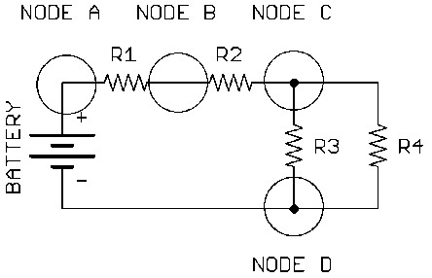**

A: Yes! Because the current flowing through R2 is the same current that enters node C and exits node D. The current splits between R3 and R4, then comes back together at node D. So considered together, R3 and R4 have the same current flowing through them as R2. A:

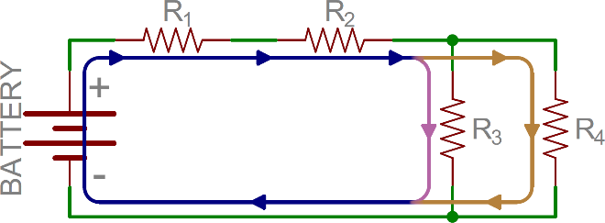

* In the circuit diagram below, are R1 and R3 in series or in parallel? A:

**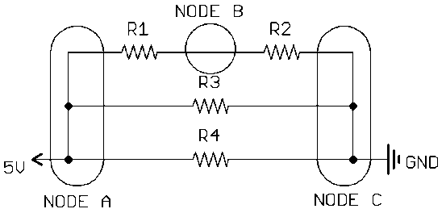**

A: Neither! The same current does not flow through each of them, it splits at node A. R1 and R2, in combination, are in parallel with R3 and R4. We cannot say that R1 alone is in parallel with R3 and R4, we need to group R1 and R2 together.

* Add a button to the buzzer circuit so that pressing the button makes it louder. A:

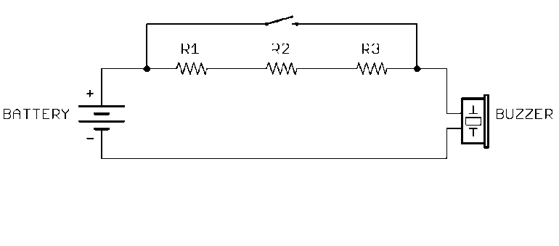

* Add 3 buttons to the parallel resistor circuit so that pressing each button increases the volume. A:

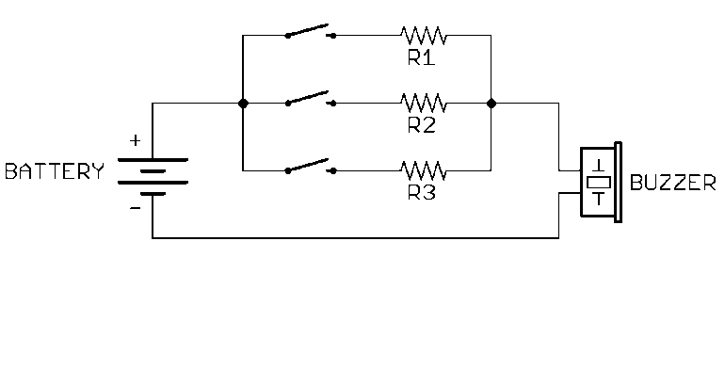

* Add three buttons to the parallel resistor circuit - two that increase the volume and one that turns the buzzer on and off (parallel and series). A:

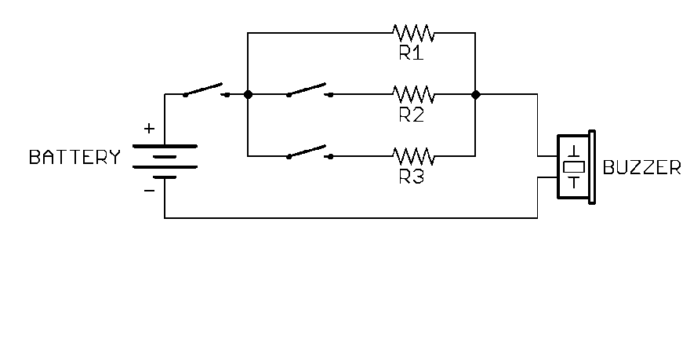

Frequently Asked Questions

How do I make series resistor connections on a breadboard? A:

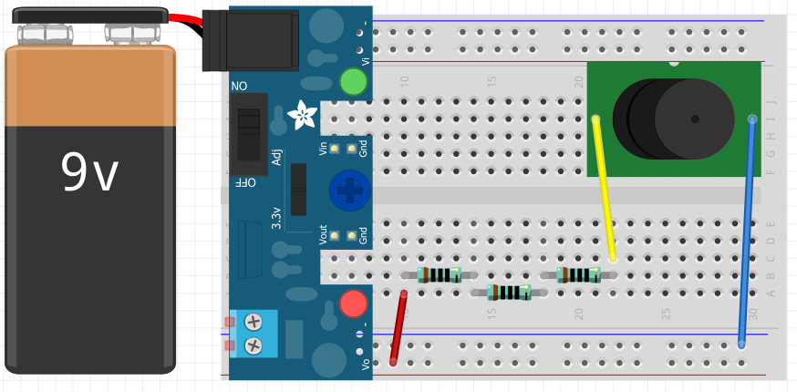[[3]](#footnote-3)

How do I make parallel resistor connections on a breadboard? A: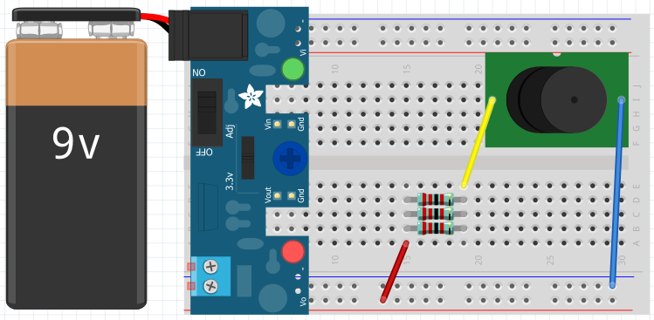

1. https://learn.sparkfun.com/tutorials/series-and-parallel-circuits [↑](#footnote-ref-1)
2. Circuit image with current flow made by Pete-O from [Sparkfun](https://learn.sparkfun.com/tutorials/series-and-parallel-circuits), [CC BY-SA 4.0](https://creativecommons.org/licenses/by-sa/4.0/) [↑](#footnote-ref-2)
3. Breadboard images made with Fritzing [↑](#footnote-ref-3)